Incoterms 2020

What are Incoterms?
Incoterms (International Commercial Terms) are internationally recognised rules that clearly define the responsibilities of buyers and sellers in international trade.
The Incoterms rules, a collection of eleven international trade clauses, are each abbreviated with three letters, e.g. DDP, FCA, FOB. They govern the main practices in the international trade between companies and define the responsibilities for costs, risks and obligations between the buyer and the seller.
The Incoterms rules describe:
- Obligations: Who does what in the relationship between the seller and the buyer, i.e. who is responsible for transporting or insuring the goods and for obtaining the shipping documents and the export or import permit?

- Risk transfer: Where and when does the seller ‘deliver’ the goods, or in other words: at what point does the risk pass from the seller to the buyer?

- Costs: Which party is responsible for which costs, e.g. transport, packaging, loading and unloading costs, inspection costs or security-related costs?

Accepted Incoterms at Manor
FCA – Free Carrier
OPTION 1
Delivery: The buyer collects the goods from the warehouse (named place) of the seller.
Risk transfer: As soon as the goods are ready for collection at the agreed location and the buyer has been informed.
Cost allocation: The buyer bears the transport risk and costs from the seller’s warehouse to the final destination.
OPTION 2
Delivery: The seller delivers the goods to a named place (e.g. freight terminal).
Risk transfer: As soon as the goods are available at the named place.
Cost allocation: The seller bears the risk and costs up to the named place.

Please note:
FCA is suitable for all modes of transport (road, air, water, rail).
Particularly flexible thanks to the two options:
- Collection from the seller
- Delivery to a named place
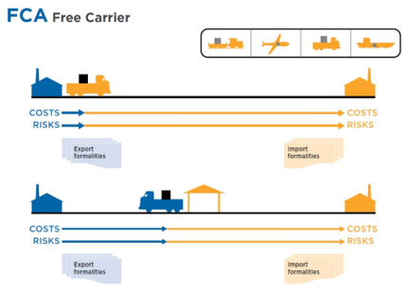
Buyer
Seller

FOB – Free on Board
Delivery: The goods are loaded onto the vessel designated by the buyer at the port of shipment.
Risk transfer: As soon as the goods have been loaded onto the vessel designated by the buyer.
Costs:
- The seller bears the costs until loading.
- The buyer bears the costs from this point onwards, including sea freight, insurance, customs
Please note: Only suitable for sea freight.
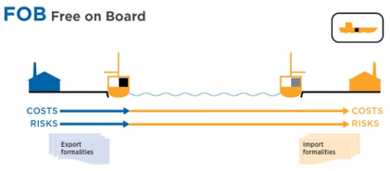
Buyer
Seller
DDP – Delivered Duty Paid
Delivery: To the named destination in Switzerland – including customs clearance and payment of Swiss value-added tax.
Risk transfer: Ready for unloading from the means of transport at the agreed destination (e.g. Möhlin distribution centre warehouse ramp, etc.).
Costs:
- The seller bears all costs up to the destination (e.g. Möhlin distribution centre warehouse ramp) including customs and VAT.
- The buyer assumes the costs and risks of the goods as soon as the vehicle is ready for unloading at the destination specified by the buyer.
Specific requirements at Manor:
- Suppliers abroad must be subject to VAT in Switzerland and have a tax representative with a valid subordination declaration (‘Unterstellungserklärung’).
- In this case, the supplier or their representative acts as the importer.
- Invoice currency: Swiss francs (CHF) including Swiss VAT of 8.1% on the invoice.
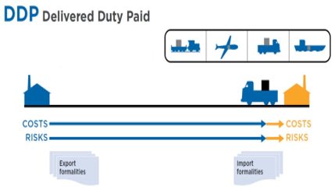
Seller
Buyer

If you have any questions about Incoterms or specific delivery conditions, please contact the Supply Chain Import department at importabteilung@manor.ch.

