Basel, September 2022

**Guidelines for invoice issuing and dispatch for NON - Markant partners**

1. **New billing addresses for goods invoices – non-Markant partners**

These address changes apply without exception to all partners who do **not** process their invoices via Markant.

The billing addresses are changing in line with the overview of mailing addresses for Manor locations. (See link: <https://www.manor.ch/de/u/suppliers-en>) under section "3 Invoice handling process" → addresses of establishments Manor. In addition, the correct Rayon number is required for warehouses and the correct group must be specified for distribution centres.

**Column A** (Products) contains the relevant billing addresses

**Column E** (Main delivery address) indicates the main delivery addresses

*Excerpt from the list:* [*https://www.manor.ch/de/u/suppliers-en*](https://www.manor.ch/de/u/suppliers-en)

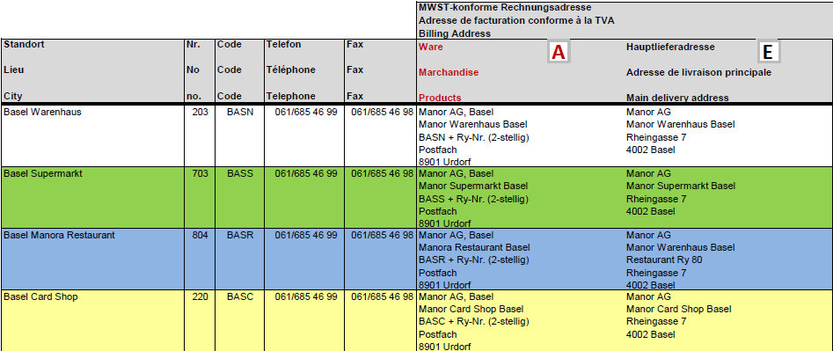

1. **New billing addresses for goods invoices – Markant partners**

Markant partners only obtain Manor billing and delivery addresses from Markant Syntrade Schweiz AG. If you have not received the necessary addresses, please send an email to the following address:

[servicecenter@ch.markantsyntrade.com](mailto:servicecenter@ch.markantsyntrade.com)

1. **New billing addresses for operating cost & investment invoices – non-Markant partners**

In addition to all the other requirements, operating cost and investment invoices must include information about the cost centre manager.

For operating cost invoices: KR Peter Muster

For investment invoices: INV Peter Muster

The abbreviations and names mentioned above are mandatory.

The billing addresses are changing in line with the overview of Manor locations. See link: [https://www.manor.ch/de/u/suppliers](https://www.manor.ch/de/u/suppliers-en) .

The billing address for operating costs can be found in **column B** **(Costs)**

The billing address for investments can be found in **column C (Investments**)

*Excerpt from the list:* [*https://www.manor.ch/de/u/suppliers-en*](https://www.manor.ch/de/u/suppliers-en)

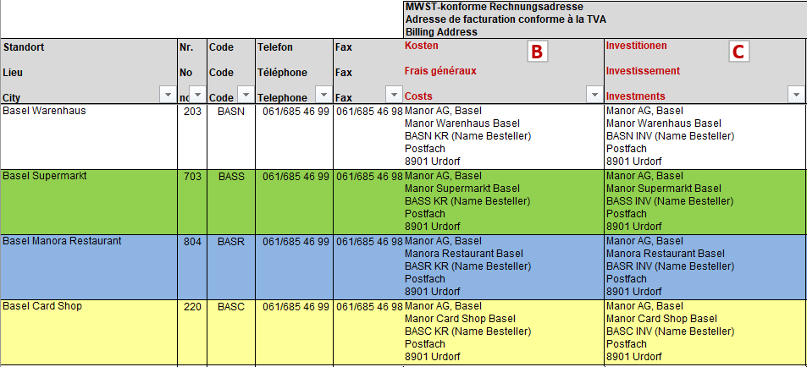

1. **New billing addresses for operating cost & investment invoices – Markant partners**

Markant partners only obtain Manor billing and delivery addresses from Markant Syntrade Schweiz AG. If you have not received the necessary addresses, please send an email to the following address:

[servicecenter@ch.markantsyntrade.com](mailto:servicecenter@ch.markantsyntrade.com)

1. **Correspondence address – valid for all partners**

For all correspondence with Manor (except invoices and reminders), please use our correspondence address.

The correspondence addresses are changing in line with the overview of Manor locations. See link: <https://www.manor.ch/de/u/suppliers-en> under section "3 Invoice handling process" → addresses of establishments Manor.

Please only use the address specified in **column D**.

*Excerpt from the list:* [*https://www.manor.ch/de/u/suppliers-en*](https://www.manor.ch/de/u/suppliers-en)

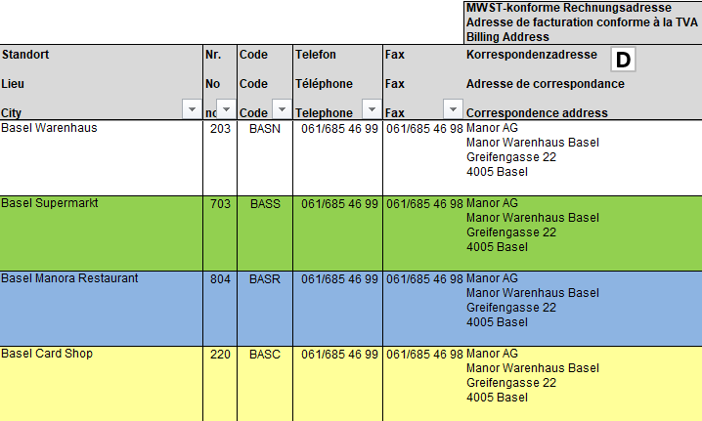

1. **Invoice dispatch – valid for all partners**

**Non-Markant:**

Invoices are to be sent exclusively by e-mail to the following address:

[invoice@manor.ch](mailto:invoice@manor.ch)

However, this is subject to the following conditions:

* For each document 🡪 one PDF file.
* No double submission.
* Only invoices and credit notes will be accepted.
* This address is not valid for Markant partners.

If it is not possible to send the invoice by e-mail, you can alternatively send the original invoice to the P.O. Box address in 8901 Urdorf (see invoice address).

1. **Invoicing – valid for all partners**

**General information**:

In accordance with our General Terms and Conditions of Purchase, the following points must be observed:

* One order / one delivery / one invoice.

Only one Manor order number per invoice.

* Only delivered items may be invoiced.
* The Manor order number must always be included in the invoice header on all documents (order confirmations, delivery slips, invoices and credit notes).
* The invoice must not be sent before the products have been delivered.
* Monthly invoices (several orders) are not accepted.

**Invoice header**:

* The Manor order number must always be included in the invoice header on all documents (order confirmations, delivery slips, invoices and credit notes).
* It is compulsory to specify the MPC in the address on our product invoices.

**Invoice content**:

* The invoice must include the Manor item numbers, item descriptions with size and colour details (if available), as well as the quantity actually delivered and the agreed purchase price. This agreed purchase price must be identical to the price stated on Manor’s purchase order.
* If the item details mentioned above are not included, timely processing and payment cannot be guaranteed.

**Invoice footer**:

The following information must be included in the invoice footer:

* Totals of the product values and the invoiced quantities.
* The ancillary costs of the products (postage, surcharges, deductions, etc.).
* The net merchandise value of the invoice for all product items (used as the basis for calculating VAT).
* The net merchandise value of the invoice per rate of VAT (if several rates apply).
* The total amount subject to VAT per VAT rate (even if there are multiple rates).
* The total amount subject to VAT (all VAT rates).
* All VAT percentages applied on the invoice.
* The gross invoice amount.

1. **Additional contact addresses – valid for all partners**

**Non-Markant:**

Any other queries can be sent to the following contact addresses:

Payment complaints: [ap.query@manor.ch](mailto:ap.query@manor.ch)

Reimbursements: Please contact the buyer responsible.

EDI requests: [edi.support@manor.ch](mailto:edi.support@manor.ch)

**Markant:**

Payment complaints: [servicecenter@ch.markantsyntrade.com](mailto:servicecenter@ch.markantsyntrade.com)

Reimbursements: Please contact the buyer responsible.

EDI requests: [servicecenter@ch.markantsyntrade.com](mailto:servicecenter@ch.markantsyntrade.com)

1. **Links**

General Terms and Conditions of Purchase

<https://manor.a.bigcontent.io/v1/static/suppliers-terms-and-conditions-2022-09-02-en>

Global Location Number (GLN)

<https://manor.a.bigcontent.io/v1/static/Neu-GLN-Address-list-Manor-PROD-2022-08-25-v2>