CD1 / Transit – Example Invoice for NON Markant

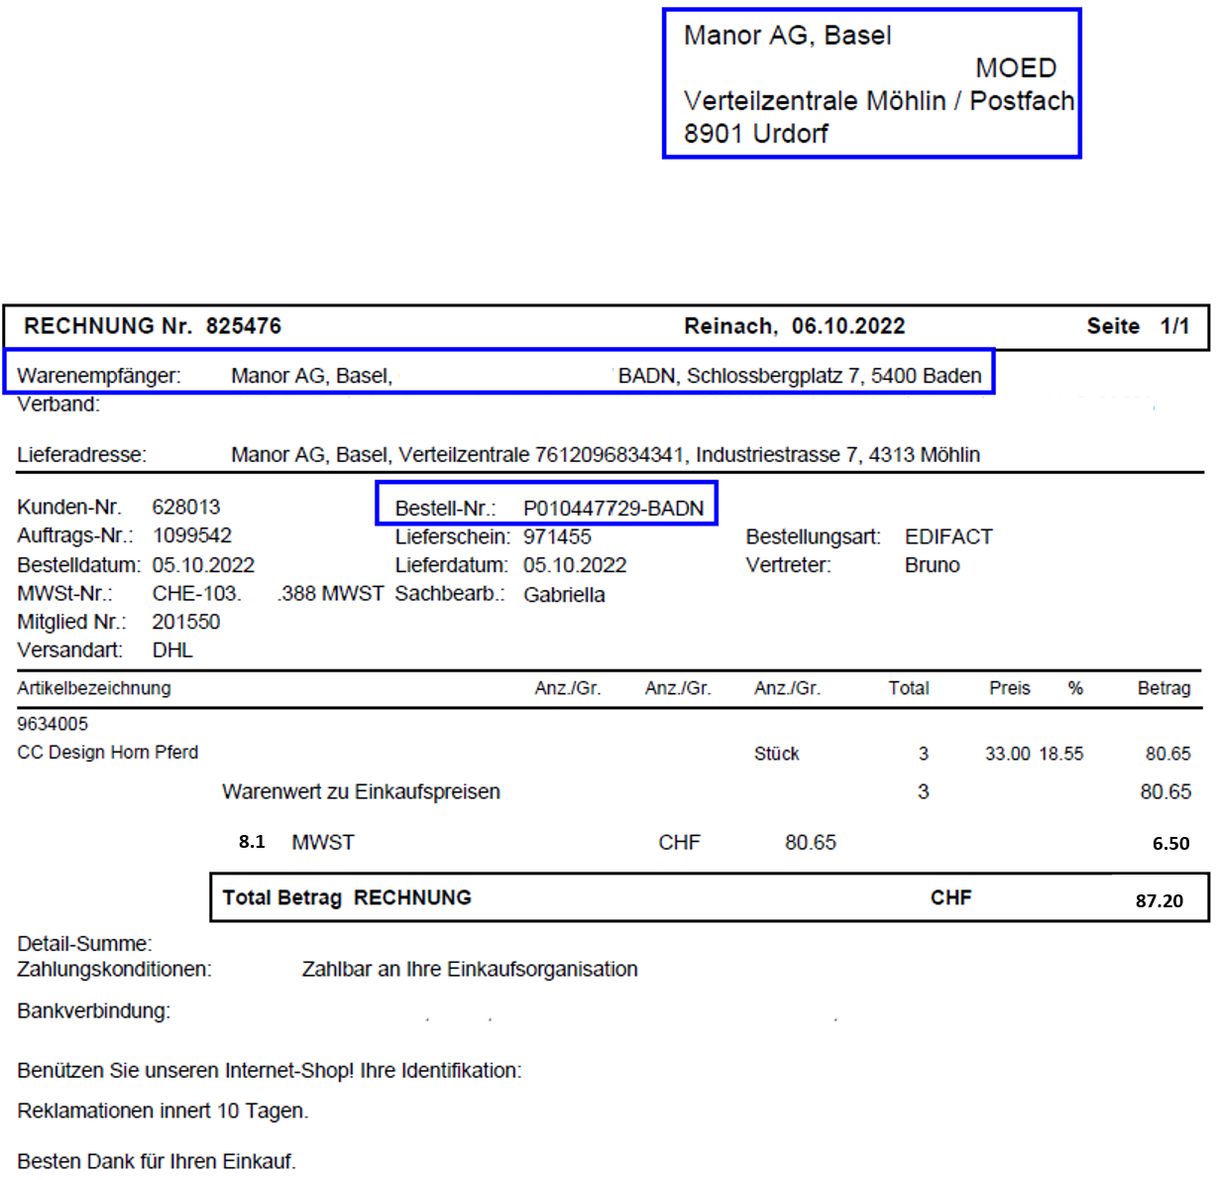

Stock – Example Invoice for NON Markant

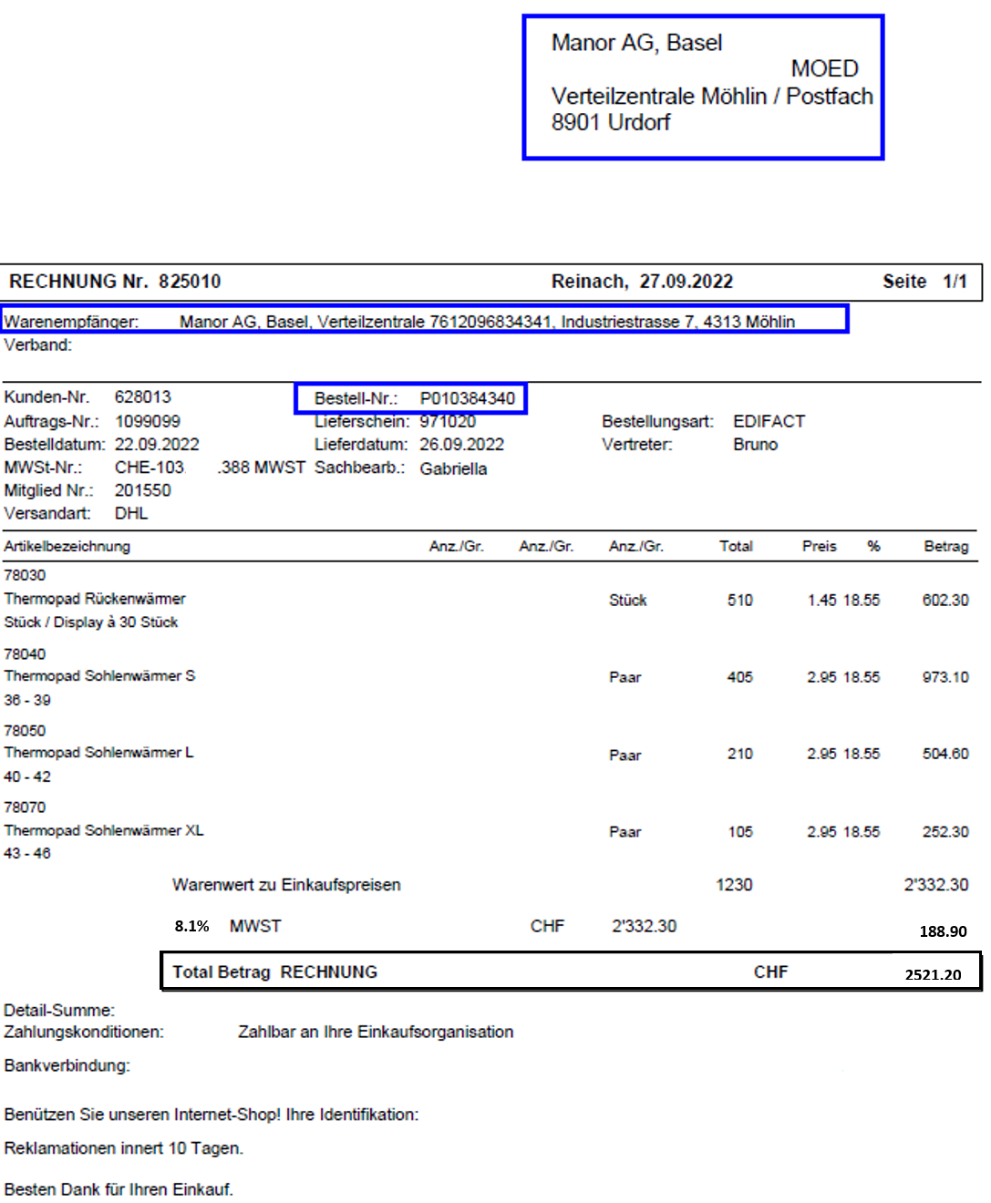

Direct Delivery – Example Invoice for NON Markant

