CD1 / Transit – Example Invoice for Markant
GLN number is a MUST

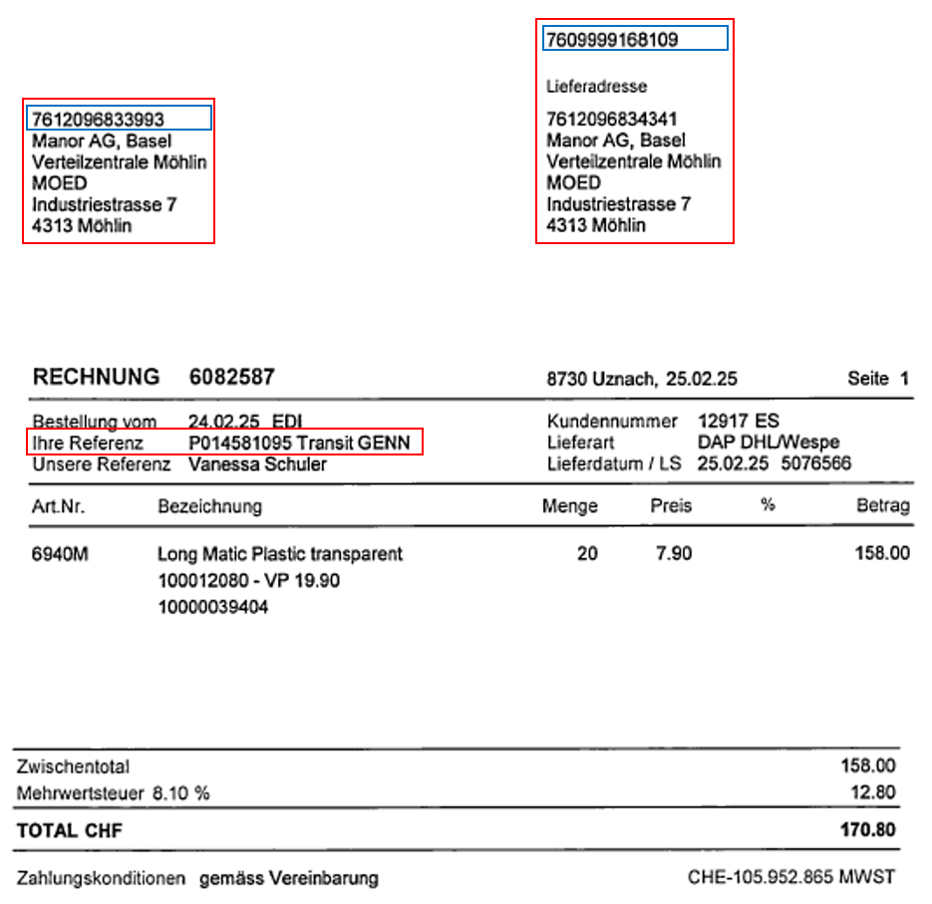

Stock – Example invoice for Markant
GLN number is a MUST

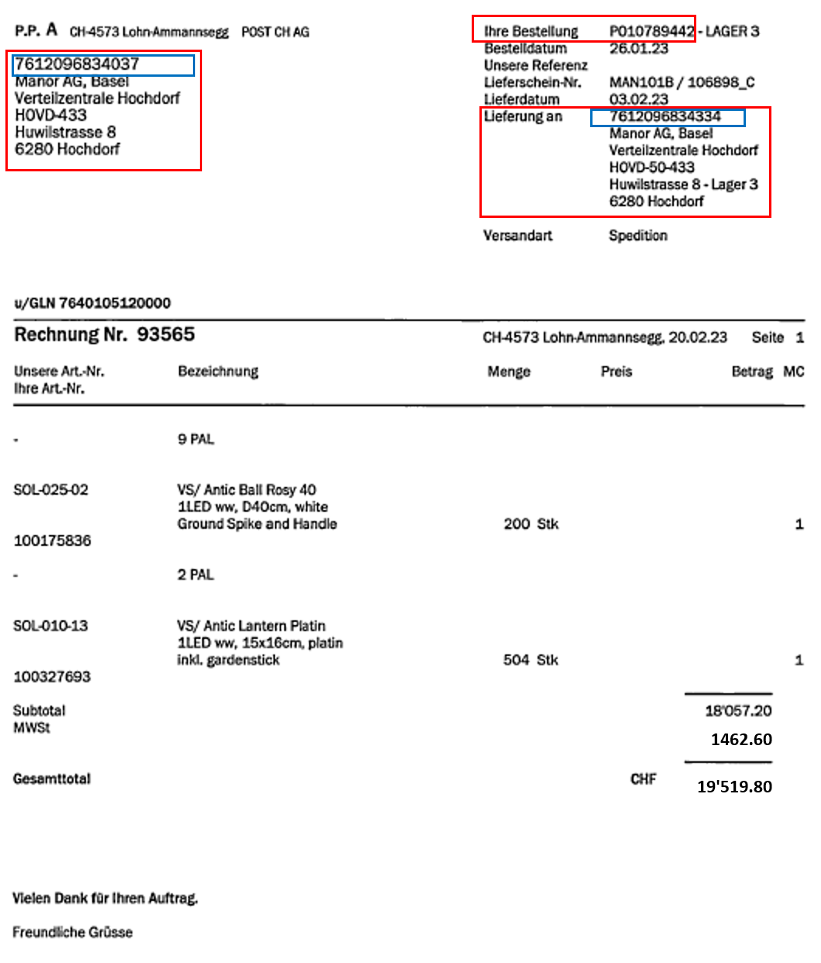

Direct Delivery – Example invoice for Markant
GLN number is a MUST

